DEPARTMENT OF CSE, CS&IT, AI&DS
COURSE CODE: 24SDCS02 / 24SDCS02E / 24SDCS02P / 24SDCS02L
FULL STACK APPLICATION DEVELOPMENT
Name: SHAIK KHAJA AMEEN ID: 2400030234

SKILL - 5 Spring Autowiring Demo using @Autowired

Prerequisites:
- General Idea on Spring Framework
- Modules of Spring Framework
- Understanding of Autowiring concepts

Problem Statement
A college application maintains student information along with their certification details.
The Student object contains a Certification object, and instead of creating it manually, Spring should automatically inject it using @Autowired.
When classes are marked with @Component, Spring creates and manages them in the IoC container.

SkillExp5AutowiredApplication.java:-

package com.klu;

import org.springframework.boot.SpringApplication;
import org.springframework.boot.autoconfigure.SpringBootApplication;

@SpringBootApplication
public class SkillExp5AutowiredApplication {

public static void main(String[] args) {
SpringApplication.run(SkillExp5AutowiredApplication.class, args);
}

}
AppConfig.java:-
package com.klu.config;

import org.springframework.context.annotation.ComponentScan;
import org.springframework.context.annotation.Configuration;

@Configuration
@ComponentScan(basePackages="com.klu.model")

public class AppConfig {

}
MainApp.java:-
package com.klu.main;

import org.springframework.context.ApplicationContext;
import org.springframework.context.annotation.AnnotationConfigApplicationContext;

import com.klu.config.AppConfig;
import com.klu.model.Student;

public class MainApp {
public static void main(String args[]) {

ApplicationContext c=new AnnotationConfigApplicationContext(AppConfig.class);
Student s=c.getBean(Student.class);
s.display();
}

}
Certification.java:-
package com.klu.model;

import org.springframework.stereotype.Component;

@Component

public class Certification {
private int id;
private String name;
private String completionDate;

public Certification() {
this.id=5864;
this.name="GitHub-Copilot";
this.completionDate="3-12-2025";
}

public int getId() {
return id;
}

public String getName() {
return name;
}

public String getCompletionDate() {
return completionDate;
}

}
Student.java:-
package com.klu.model;

import org.springframework.beans.factory.annotation.Autowired;
import org.springframework.stereotype.Component;

@Component
public class Student {
private int stuId;
private String stuName;
private String gender;

@Autowired
private Certification certification;

public Student() {
this.stuId=586;
this.stuName="Shaik Khaja Ameen";
this.gender="Male";
}

public void display() {
System.out.println("Student Id: "+stuId);
System.out.println("stuName: "+stuName);
System.out.println("Gender: "+gender);
System.out.println("");
System.out.println("Certification Course Id: "+certification.getId());
System.out.println("Certification Course Name: "+certification.getName());
System.out.println("Completion Date: "+certification.getCompletionDate());

}

}

Outputs:
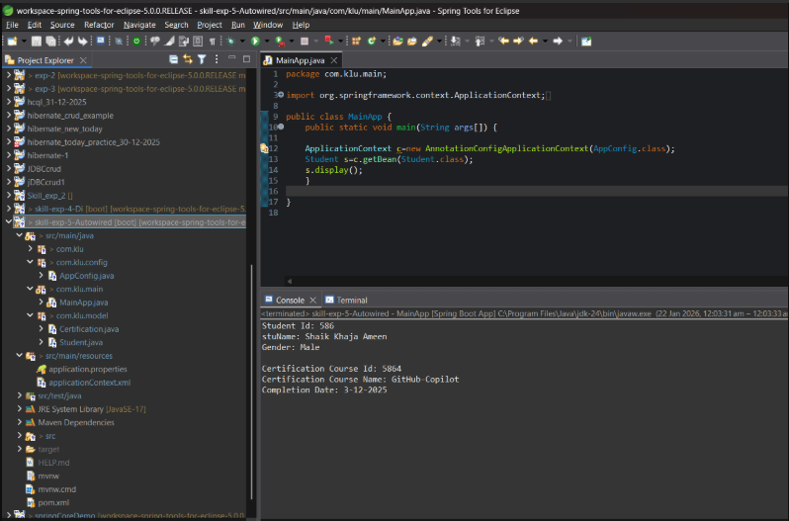

- Push the project into a single GitHub repository.

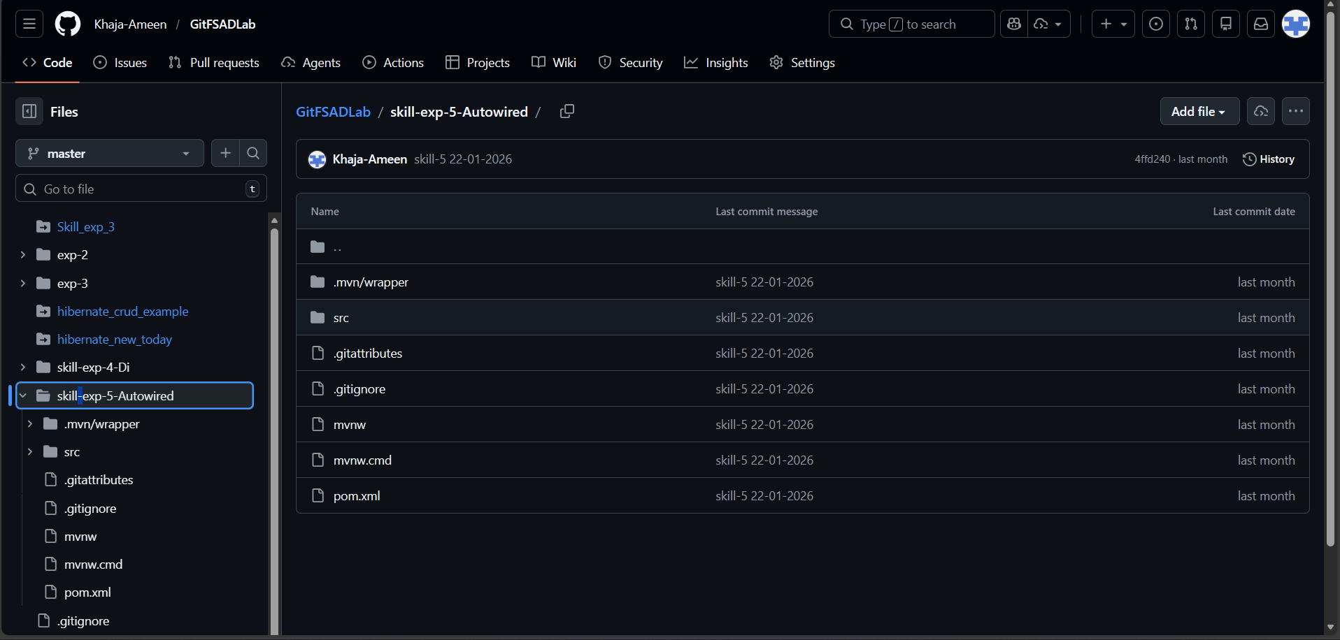

Viva Questions:-
1.What is autowiring in Spring?
Autowiring is automatic dependency injection performed by Spring.
2. What is the purpose of the @Autowired annotation?
It automatically injects required dependency beans into a class.
3. How does Spring choose which bean to inject?
Spring injects the bean based on type matching by default.
4.What is component scanning in Spring?
Component scanning automatically detects and registers @Component classes as beans.
5.What happens if more than one bean matches the dependency type?
Spring throws NoUniqueBeanDefinitionException unless @Qualifier is used.

(For Evaluator’s use only)
Comment of the Evaluator (if Any)

Evaluator’s Observation
Marks Secured: out of
EMP ID & Full Name of the Evaluator:

Signature of the Evaluator Date of Evaluation

